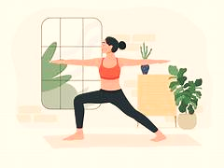
The power of yoga enhances self-care!

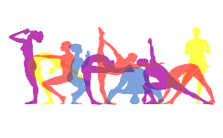

Overview
Yoga is well-known for its power to create a healthy body. Of course, it enhances the emotional and spiritual practices. It is excellent relaxation exercise for people to relieve stress. It subtly transforms our relationship with ourselves, boost our mood, reduce stress and lead to healthier life.

NECESSARY EQUIPMENTS: YOGA POSES
1.Yoga Mats: For a strong grip (eco-friendly)
2.Yoga blocks and straps: Helpful in flexibility, stability
3. Activewears: Comfortable and outfits for yoga poses
4. Bolster: Cylindrical pillows dot relaxation and release tension
5. Yoga Towels: For vigorous yoga practices
6.Water bottles: Keep us hydrated

2

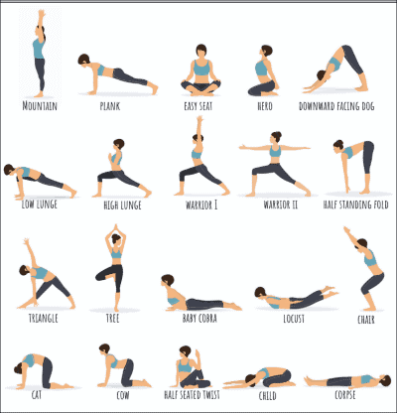

STEPS AND INSTRUCTION FOR HOME YOGA
1.Choose the suitable, cluster-free area to have sound yoga practices with the flexible periods.
2.Begin the yoga session with gentle warm-up to aware body and mind with passive stretch. Proceed to short and gradual increase of the length of the yoga practices.
3.Stick with the consistent yoga schedule. We have a lot of resources for examples, books, multimedia’s resources for guidelines. Always be focus on fundamental poses and postures, alignment, breath awareness, balance, and mindfulness. Ensure to practice safely and effectively.
4.Start with simple poses, and determine to be gentle with yourself and accelerate yoga like Mountain’s pose, child’s pose, cat-cow’s pose, downward-facing dog’s pose etc. Please listen to your body and mind. Avoid jerking in position which can strain the joint and muscles. So, practice with control.
5.Pay attention to your yoga poses, breath, the body sense, it is always smart to practice slow with deep breathing, inhaling, exhaling through nose. It helps to stay presence, calm and enhances the yoga practices.
6.Drink plenty of fluid before, during, and after the yoga practices and give time to rest and recover.
7.End the day with relaxation. Lie down on your back, close your eyes, and allow your body to relax completely. And keep enjoying and exploring the yoga at home.


WARNING!
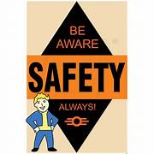
# Re-evaluate the foundation of your yoga practices and don’t push yourself beyond your health, could caught serious injuries!

Sources: www.yogabasics.com, Image.search.yahoo.com

